

OPC Test Lab Specification
Part 1: Concepts
Release Candidate Version 1.00.01
Jan 24, 2008
Send comments to:
ComplianceComments@opcfoundation.org

Specification Type | Industry Standard Specification
Title: | OPC Test Lab Specification  Part 1: Concepts | Date: | Jan 24, 2008
Version: | Release Candidate 1.00.01 | Software | MS-Word
 |  | Source: | 0000.doc
Author: | OPC Foundation | Status: | Release Candidate

CONTENTS

Page

FOREWORD v
AGREEMENT OF USE v
1 Scope 1
2 Reference documents 1
3 Terms, definitions, and abbreviations 1
3.1 OPC Certification terms 1
3.1.1 Board of Directors 1
3.1.2 Technical Advisory Council 1
3.1.3 Compliance Testing 1
3.1.4 Compliance Test Tool 1
3.1.5 Interoperability Testing 2
3.1.6 Interoperability Workshop 2
3.1.7 Certification Testing 2
3.1.8 Certification Test Lab 2
3.2 Abbreviations and symbols 2
4 Structure of the OPC Test Lab series 3
4.1 Specification Organization 3
4.2 Specification Parts 3
4.2.1 Part 1 – OPC Certification Concepts 3
4.2.2 Part 2 – Abstract Test Suite 3
4.2.3 Part 3 - Test Lab Realization 4
4.2.4 Part 4 – Certification Process 4
4.2.5 Part 5 – Quality Management Manual 4
4.2.6 Part 6 – COM DA Server Test 4
4.2.7 Part 7 – COM DA Client Test 4
4.2.8 Part 8 – UA Server Test 4
4.2.9 Part 9 – UA Client Test 4
4.2.10 Part 10 – UA Abstract Test 4
4.2.11 Part 11 – COM A&E Server Test 4
4.2.12 Part 12 – COM A&E Client Test 4
4.2.13 Part 13 – COM HDA Server Test 4
4.2.14 Part 14 – COM HDA Client Test 4
5 General Introduction to OPC Certification 5
5.1 Goals for OPC Certification 5
5.1.1 OPC Foundation 5
5.1.2 OPC Product Vendors 5
5.1.3 OPC End Users 5
5.2 OPC Certification Testing 6
5.3 OPC Interoperability Workshops 7
5.4 OPC Compliance Test 8
5.5 OPC Compliance Test (client) 8
5.6 OPC Certification Test Lab 8
5.7 OPC Certification Module Overview 9
6 Test Lab Certification Process Overview 11
7 Test implementation 12
8 Certificate Expiration 12
9 Multi Protocol Servers Certification 13
10 Certification Logo 13

Figures
Figure 1 – OPC Test Lab Specification Organization 3
Figure 2 - Client OPC Certification Testing 6
Figure 3 – Server OPC Certification Testing 7
Figure 4 – OPC Test Lab Certification Process 11

Tables
Table 1 – Overview test coverage OPC Server 10
Table 2 – Benefits of OPC Certification 10

OPC Foundation
____________

OPC Test Lab Certification

FOREWORD
This specification is intended for developers and users of the OPC Certification Test Lab. Its goal is to define a certification process to ensure interoperability between OPC server and client products.
Copyright © 2006, OPC Foundation, Inc.
AGREEMENT OF USE
COPYRIGHT RESTRICTIONS
Any unauthorized use of this specification may violate copyright laws, trademark laws, and communications regulations and statutes. This document contains information which is protected by copyright. All Rights Reserved. No part of this work covered by copyright herein may be reproduced or used in any form or by any means--graphic, electronic, or mechanical, including photocopying, recording, taping, or information storage and retrieval systems--without permission of the copyright owner.
OPC Foundation members and non-members are prohibited from copying and redistributing this specification. All copies must be obtained on an individual basis, directly from the OPC Foundation Web site
http://www.opcfoundation.org.
PATENTS
The attention of adopters is directed to the possibility that compliance with or adoption of OPC specifications may require use of an invention covered by patent rights. OPC shall not be responsible for identifying patents for which a license may be required by any OPC specification, or for conducting legal inquiries into the legal validity or scope of those patents that are brought to its attention. OPC specifications are prospective and advisory only. Prospective users are responsible for protecting themselves against liability for infringement of patents.
WARRANTY AND LIABILITY DISCLAIMERS
WHILE THIS PUBLICATION IS BELIEVED TO BE ACCURATE, IT IS PROVIDED "AS IS" AND MAY CONTAIN ERRORS OR MISPRINTS. THE OPC FOUDATION MAKES NO WARRANTY OF ANY KIND, EXPRESSED OR IMPLIED, WITH REGARD TO THIS PUBLICATION, INCLUDING BUT NOT LIMITED TO ANY WARRANTY OF TITLE OR OWNERSHIP, IMPLIED WARRANTY OF MERCHANTABILITY OR WARRANTY OF FITNESS FOR A PARTICULAR PURPOSE OR USE. IN NO EVENT SHALL THE OPC FOUNDATION BE LIABLE FOR ERRORS CONTAINED HEREIN OR FOR DIRECT, INDIRECT, INCIDENTAL, SPECIAL, CONSEQUENTIAL, RELIANCE OR COVER DAMAGES, INCLUDING LOSS OF PROFITS, REVENUE, DATA OR USE, INCURRED BY ANY USER OR ANY THIRD PARTY IN CONNECTION WITH THE FURNISHING, PERFORMANCE, OR USE OF THIS MATERIAL, EVEN IF ADVISED OF THE POSSIBILITY OF SUCH DAMAGES.
The entire risk as to the quality and performance of software developed using this specification is borne by you.
RESTRICTED RIGHTS LEGEND
This Specification is provided with Restricted Rights. Use, duplication or disclosure by the U.S. government is subject to restrictions as set forth in (a) this Agreement pursuant to DFARs 227.7202-3(a); (b) subparagraph (c)(1)(i) of the Rights in Technical Data and Computer Software clause at DFARs 252.227-7013; or (c) the Commercial Computer Software Restricted Rights clause at FAR 52.227-19 subdivision (c)(1) and (2), as applicable. Contractor / manufacturer are the OPC Foundation,. 16101 N. 82nd Street, Suite 3B, Scottsdale, AZ, 85260-1830
COMPLIANCE
The OPC Foundation shall at all times be the sole entity that may authorize developers, suppliers and sellers of hardware and software to use certification marks, trademarks or other special designations to indicate compliance with these materials. Products developed using this specification may claim compliance or conformance with this specification if and only if the software satisfactorily meets the certification requirements set by the OPC Foundation. Products that do not meet these requirements may claim only that the product was based on this specification and must not claim compliance or conformance with this specification.
Trademarks
Most computer and software brand names have trademarks or registered trademarks. The individual trademarks have not been listed here.
GENERAL PROVISIONS
Should any provision of this Agreement be held to be void, invalid, unenforceable or illegal by a court, the validity and enforceability of the other provisions shall not be affected thereby.
This Agreement shall be governed by and construed under the laws of the State of Minnesota, excluding its choice or law rules.
This Agreement embodies the entire understanding between the parties with respect to, and supersedes any prior understanding or agreement (oral or written) relating to, this specification.
ISSUE REPORTING
The OPC Foundation strives to maintain the highest quality standards for its published specifications, hence they undergo constant review and refinement. Readers are encouraged to report any issues and view any existing errata here:
http://www.opcfoundation.org/errata.

Scope
This specification presents the general concepts for OPC Test Lab Certification.
The interoperability of the member developed components, and the compliance of these components to OPC specifications are critical to the success of the OPC Foundation and its members. In addition the quality and reliability in combination with performance and ease of use are crucial to increasing the use of OPC Interfaces in different branches of industry.
To help increase the quality, robustness and interoperability of OPC Client and Server products, this document gives a conceptual overview on the certification process including independent laboratory testing. This document is part of a multipart specification which forms the basis for development, operation and distribution of OPC Test Labs. It is addressed especially to the test departments, development leads, quality assurance managers and other technical staff of the OPC Member companies. Since Parts 1-5 of this document deals with fundamental test concepts and the process of certification, this document also speaks to management.
The details of the Certification Logo Program and the visibility of the OPC Certification to the end users of the OPC products will be addressed in a separate document.

Reference documents
There are no reference documents.

Terms, definitions, and abbreviations
For the purposes of this specification, the following definitions apply

OPC Certification terms

Board of Directors
The OPC Foundation is governed by a Board of Directors elected by the membership. The Board, in turn, appoints the Foundation's Officers and the OPC Chief Architect.

Technical Advisory Council
The OPC Foundation’s Technical Advisory Council (TAC) advises the OPC Foundation management on current and future technical matters and in general, guides the technical direction of the Foundation. Specific tasks include commissioning new work by approving Technical Working Group charters and final release approval of all Technical Working Group

Compliance Testing
The testing of the client and/or server interfaces to validate conformance to the appropriate OPC specification.

Compliance Test Tool
The automated testing of the server interfaces to validate conformance to the appropriate OPC specification. The compliance test calls all of the methods of the server application with both valid and invalid parameters and compares the results with the expected behavior.

Interoperability Testing
The testing of the interaction between several OPC client and server products from different vendors in normal operation.

Interoperability Workshop
A test workshop, regularly hosted, with changing participants testing interoperability between their products.

Certification Testing
Certification Testing is the process of testing of OPC clients and servers. The tests validate that the product meets the quality standards defined by the OPC Foundation.

Certification Test Lab
The test laboratory that executes certification tests for OPC products. The tests are defined by the OPC Foundation and must be identical for all test labs.

Abbreviations and symbols
CTT Compliance Test Tool
IOP Interoperability Workshop
TSC Technical Steering Committee
A&E Alarms and Events
API Application Programming Interface
COM Component Object Model
DA Data Access
DCOM Distributed COM
DCS Distributed Control System
DX Data Exchange
HDA Historical Data Access
PLC Programmable Logic Controller
SOAP Simple Object Access Protocol
UA Unified Architecture
UML Unified Modeling Language
WSDL Web Services Definition Language
XML Extensible Markup Language

Structure of the OPC Test Lab series

Specification Organization
This specification is organized as a multi-part specification, as illustrated in Figure 1.
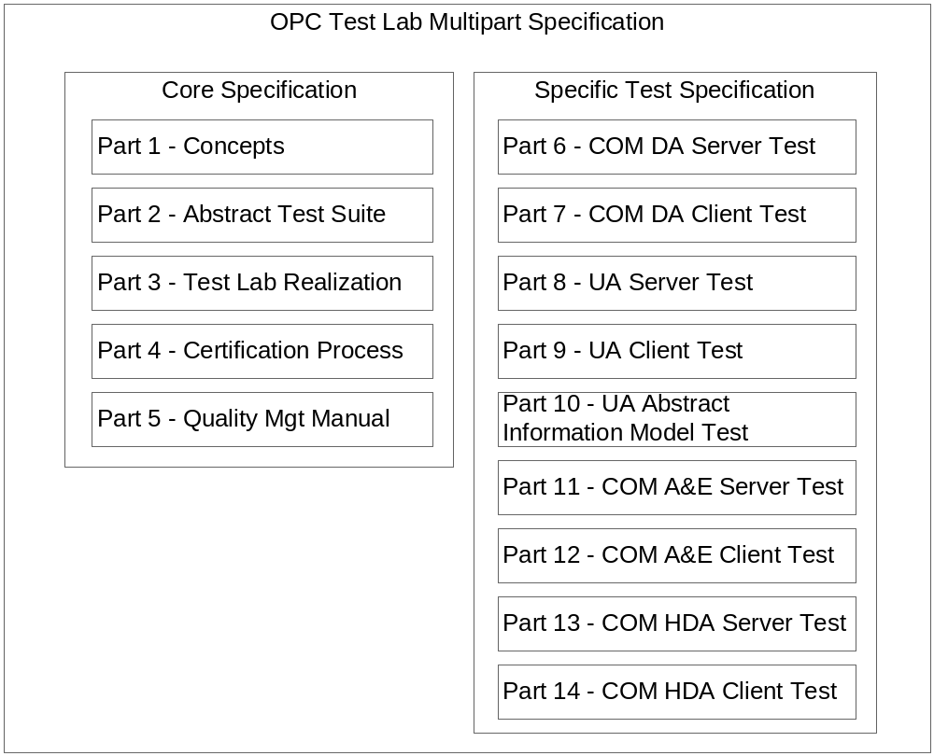

Figure 1 – OPC Test Lab Specification Organization
Parts 1 through 5 specify the general Test Lab environment and the OPC Test Lab Certification process. Parts 6 through 14 define the test instructions for a specific OPC Server or Client certification.
Readers are encouraged to read Part 1 and Part 2 of the core specifications before reading Parts 6 through 10. For example, those interested in OPC Data Access Client certification should read Parts 1, 2 and 7. References in Part 7 may direct the reader to other parts of this specification. Parts 3 through 5 are the base for the Test Lab organization to ensure the same quality and result in all Test Labs.

Specification Parts

Part 1 – OPC Certification Concepts
Part 1 of the OPC Test Lab multi-part specification presents the general concepts for OPC Test Lab Certification.

Part 2 – Abstract Test Suite
Part 2 of the OPC Test Lab multi-part defines an abstract test suite for OPC Client and OPC Server certification in a Certification Test Lab.

Part 3 - Test Lab Realization
Part 3 of the OPC Test Lab multi-part specification defines how to gain accreditation and how to run an accredited OPC Certification Test Lab.

Part 4 – Certification Process
Part 4 of the OPC Test Lab multi-part specification defines the process to certify a product in an OPC Test Lab.

Part 5 – Quality Management Manual
Part 5 of the OPC Test Lab multi-part specification provides the Quality Management Manual for an OPC Test Lab ensuring the same test quality in all OPC Test Labs.

Part 6 – COM DA Server Test
Part 6 of the OPC Test Lab multi-part specification defines the test instructions for an OPC COM Data Access Server.

Part 7 – COM DA Client Test
Part 7 of the OPC Test Lab multi-part specification defines the test instructions for an OPC COM Data Access Client.

Part 8 – UA Server Test
Part 8 of the OPC Test Lab multi-part specification defines the test instructions for an OPC Unified Architecture Server.

Part 9 – UA Client Test
Part 9 of the OPC Test Lab multi-part specification defines the test instructions for an OPC Unified Architecture Client.

Part 10 – UA Abstract Test
Part 10 of the OPC Test Lab multi-part specification defines the test instructions for the OPC Unified Architecture Abstract Information Model.

Part 11 – COM A&E Server Test
Part 11 of the OPC Test Lab multi-part specification defines the test instructions for an OPC COM Alarm & Events Server.

Part 12 – COM A&E Client Test
Part 12 of the OPC Test Lab multi-part specification defines the test instructions for an OPC COM Alarm & Events Client.

Part 13 – COM HDA Server Test
Part 13 of the OPC Test Lab multi-part specification defines the test instructions for an OPC COM Historical Data Access Server.

Part 14 – COM HDA Client Test
Part 14 of the OPC Test Lab multi-part specification defines the test instructions for an OPC COM Historical Data Access Client.

General Introduction to OPC Certification
The base of an OPC server or client is the specification, which describes the functionality and methods of each interface. Different vendors, working independently to develop their own clients and servers, will frequently interpret the specification differently. These differences in interpretation can cause serious problems in the interoperability of clients and servers.

Goals for OPC Certification

OPC Foundation
- Reliable OPC products with a high quality.
- Transparent testing and certification procedure.
- Approved OPC Certification™ label.

OPC Product Vendors
The OPC Certification must support OPC product vendors during the whole life cycle of the product.
Development:
- OPC specifications must be designed to prevent interoperability issues.
- Test tools available during development.
System Test:
- Reduce system test costs for interoperability tests.
- Large test coverage.
Support:
- Enhance product quality
- Reduce support costs

OPC End Users
The OPC Certification must support OPC End Users
- Certified products to assure functionality, behavior, interoperability, robustness and reliability.
- Application-related test environment.
- Results that allow easy verification of product certification.

OPC Certification Testing
The Figure 3 gives an overview of the three essential parts of the OPC Certification Testing. It is assumed that the product has passed the vendors internal system tests before being submitted for certification. The OPC Certification Testing can validate only the OPC-related functionality and cannot validate the whole application functionality of a product. However the OPC Compliance Testing may test application functionality that is not related to OPC functionality and may fail a Certification for failures on non-OPC related functionality. For example, if a Client product crashes when opening a non-OPC related menu, this would result in a certification failure. However the OPC compliance test does not claim to validate all non-OPC functionality.
General Overview
After confirming that the product passes their own tests, vendors should test OPC servers with the Compliance Test Tool (CTT). All client and server products should be tested at an Interoperability Workshop (IOP). Clients that pass OPC Analyzer testing either at the IOP or via remote OPC Analyzer execution and servers that pass the CTT and IOP will be marked “self-tested”. The test results will be published on the OPC Foundation’s website. Self-tested OPC products should then be taken to an accredited OPC Certification Test Lab. A server product must be compliance tested to start the test in an OPC Certification Test Lab. Server and client products should be tested at an Interoperability Workshop or via remote OPC Analyzer execution prior to the OPC Certification Testing in a Certification Test Lab to reduce potential problems in the test lab. Based on the scheduling of Interoperability Workshops this may not always be possible. After passing the tests of the independent lab, the product will be marked “OPC Certified”. The certificate will be published on the OPC Foundation’s website.
Figure 3 and Figure 3 show the overview about OPC Certification Testing for client and servers.
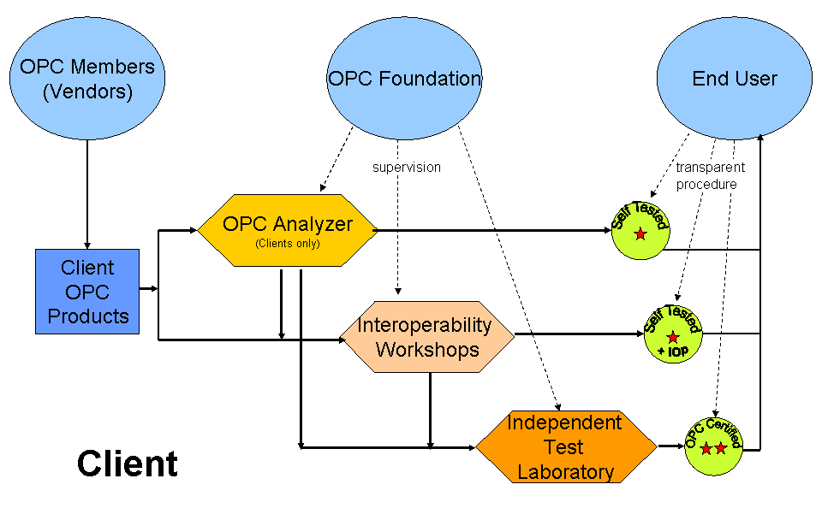
Figure 2 - Client OPC Certification Testing

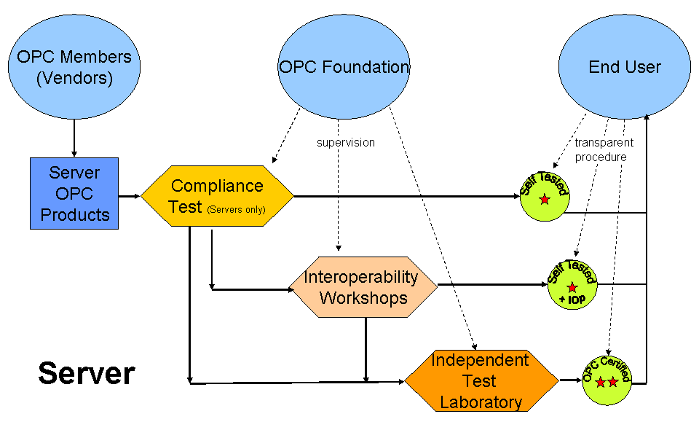

Figure 3 – Server OPC Certification Testing

OPC Interoperability Workshops
Interoperability Testing is a process in which OPC vendors test their products with the products supplied by other OPC vendors. This testing is done at events called Interoperability Workshops, hosted by the OPC Foundation three times a year - once each in Europe, the US and Japan.
The interoperability test process requires that OPC vendors run a series of standard tests for each combination of an OPC Client and an OPC Server product.
Features of the OPC Interoperability Workshops:
- Developers volunteer participation.
- Testing of Servers and Clients.
- An easy way to pass OPC Analyzer testing to get a “self-tested” logo for clients.
Limitations of the OPC Interoperability Workshops:
- Subset of interfaces under test.
- Partial coverage and varying participants produce a changed environment for each session.
- Does not necessarily represent real world use cases, loading, or failure scenarios.
Interoperability workshops provide only an informal test environment and a self test of the participating vendors. There is no confirmation that test cases are actually executed. Test tools developed for Test Lab certification should be used in future IOP workshops. It is especially important that all clients pass a test with the monitoring and error injection server (OPC Analyzer).

OPC Compliance Test
The OPC Compliance Test Tool is able to detect most of the interface problems in the server.
Features of the OPC Compliance Test:
- Fully automated self-certification.
- Black Box test.
  - Interface test.
  - Full coverage of all methods.
  - Logical Test.
- Limited Performance and Stress Test.
- Debugging support during development.

Limitations of the OPC Compliance Test:
- Testing is only available for Servers.
- No testing of logical application behavior, interoperability, reliability or full performance.
- Server test is self-executed by the vendor and is not available to end users.
- No requirements for the data set used during testing.

OPC Compliance Test (client)
. An automatic test with automatic test result generation is not available for OPC Clients. Client can be tested remotely using the same process that is provided at an IOP. This Remote OPC Analyzer testing requires that the client application and the OPC analyzer both be available via a Desktop sharing application, allowing OPC Personal to verify Client behavior during OPC Analyzer execution. This process does have a fee associated with it. The details of this process are available from the OPC Foundation WEB site

OPC Certification Test Lab
Components that use OPC-specified interfaces must undergo a complete test of their functionality and behavior to certify that they comply with the specification. Such testing can be executed only in a test lab environment.
All labs must support English for documentation. Other languages from a region should be supported by test labs in that region.
Features of an OPC Certification Test Lab:
- Reproducible environment with a fixed list of products used for Interoperability Testing.
- Functional Tests for OPC Clients and Servers.
- Behavior tests for typical and exceptional scenarios.
- Environmental tests with real device connection and device failure scenarios.
- Performance tests including long term test run and load.
How to test:
- Automated test suites and test tools are used where possible.
- Fully manual
  - Independent test personal required.
  - Vendor‘s expert attending the test run.
Where to Test:
- Lab Certification
Vendor provides the components to test and supports its configuration.
- On Site Certification (exceptional)
On Site Certification is only available in special cases where hardware is required that can not be moved to the test lab. For example an embedded controller that is running UA and requires more hardware than could be certified on site. This type of testing would require an additional review. Using an actual, vendor-related hardware environment is not the norm since, unlike lab testing, it would be difficult to reproduce test scenario. The test lab has a quality process that would not be in place at the vendor’s site, so the procedure must be reviewed and well-documented.
- Lab Testing
Test lab can validate a vendor’s or customer’s configuration on request as an additional service.
- On Site Testing
The test lab can validate a vendor’s or customer’s configuration on request as an additional service on site.
- Remote Access Based Testing
The test lab can as an additional service support remote access and remote test. OPC Members can use this service during product development and test.
When to Test:
- On demand
  - Whenever needed
  - No fixed dates, but the vendor must sign-up for blocks of dates in the test lab schedule to ensure that no parallel tests with different vendors are executed.

OPC Certification Module Overview
The test coverage for an OPC Server depends on the test procedure.
- The CTT gives a full coverage of black box test.
- The Interoperability Workshop covers compatibility between products based on a set of typically used functions.
- The Certification Test Lab provides a reproducible interoperability test, adds the real life environment and validates the behavior.
Table 1 gives an overview on the different test types and the coverage with the OPC Certification Modules.
Table 1 – Overview test coverage OPC Server
Assignment | Compliance | Interoperability | Test Lab
Black Box Testing | Full | Partial | Full
Performance Testing | Partial | -- | Almost Full
Load Testing | Partial | Partial | Full
White Box Testing | - | Little | optional
Behavior | - | Little | Full
Environment | - | Partial | Almost Full
Usability | - | - | Partial

Shows the benefits of OPC certified products to the OPC Foundation, the Vendors (Members) and the End Users. The Compliance Test Tool and the Interoperability Workshops have already improved the quality of OPC products, but these procedures cannot cover all major issues of concern. Together with accredited Certification Test Labs, they will achieve full test coverage.

Table 2 – Benefits of OPC Certification
 | End User | Vendor | OPC Foundation
CTT | Confirms server’s compliance with interface specifications | Self-certification  Debug support  Quality Label  Product catalog listing  Free of charge | Quality Label  Spec clarification  Increase value of Membership
IOP | Confirms compatibility with some OPC products  Limited confirmation of typical functionality | Multi vendor products  Limited confirmation of typical functionality  Confirms compatibility with some OPC products  Developers meeting (crucial) | Product interoperability list  Developer feedback  OPC community  Increase value of Membership
Test Lab | Comparable results  Real environment tested  High reliability  Summary overview report for End User  Detailed Test Result report for Technical review | Integration into overall system without issues  Error scenarios  System test coverage  Reduce support costs | Independent quality assurance  Accredited Certification Test Labs  Increase value of Membership

Test Lab Certification Process Overview
Part 4 of this document provides a detailed description of the Test Lab Certification process. Figure 4 illustrates the general certification process and all parties concerned.
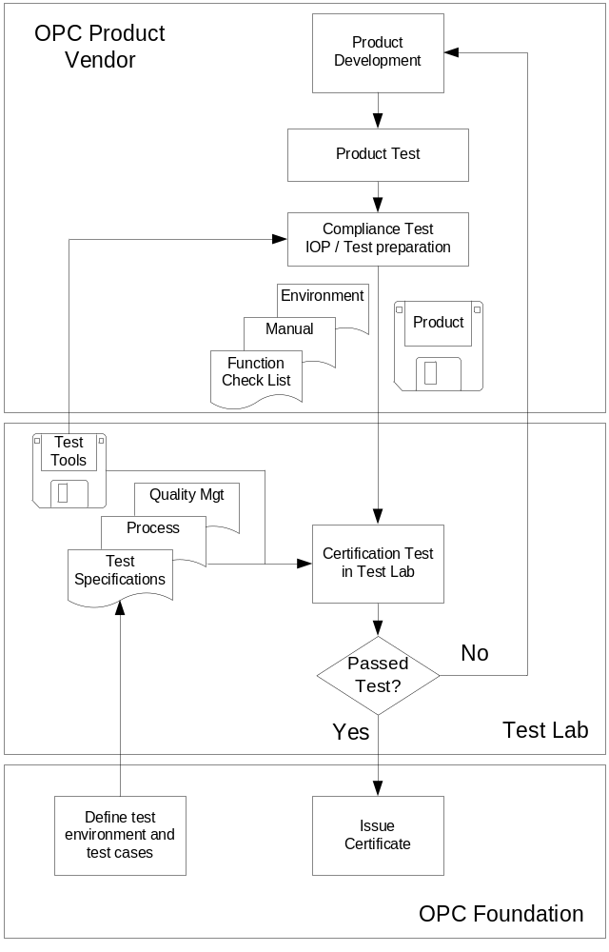

Figure 4 – OPC Test Lab Certification Process
The OPC Foundation defines the environment and the instructions for the OPC Certification testing in an OPC Certification Test Lab.
A vendor, who wants to certify an OPC product first performs its own quality testing, then schedules a test in the Certification Test Lab. In an effort to increase the odds of a successful test session in the lab, all test tools used by the Certification Test Labs will be made available to the vendors for their in-house testing. The OPC product vendor provides the Certification Test Lab with the product and all necessary documents, such as a function checklist or a description of the supported environment. The vendor also provides proof that it has completed the self-testing that is available for the product.
The Certification Test Lab executes the defined Certification Test. If the test fails, the vendor must correct the problem and then must schedule a new test. If the product passes, the test report is reviewed by the OPC Foundation and published on the OPC Foundation WEB site. The OPC Foundation issues the Certificate.

Test implementation
The abstract test suite in Part 2 of this multipart specification is the basis for the specific tests related to OPC specifications. The test specification for a particular OPC interface, such as Part 6 for OPC COM Data Access Servers and Part 7 for OPC COM Data Access Clients, must cover at least the test areas described in Part 2.
The test specifications must define instructions for each section of the required test. The instructions must describe the general test steps and the expected behavior.
The details of the test cases and the test implementation are documented outside this multipart specification. The documentation is contained in a database including:
- detailed test case description
- test tool handling
- rules for the test execution
- detailed description of the expected results
- used reference products for interoperability testing
It is expected that the test implementation is more dynamic than the documents of this multipart specification. The documentation of the test implementation must have a version number that is included in the test result.
All OPC Certification Test Labs must execute the certification tests based on the same documentation. This documentation is shared between the OPC Certification Test Labs as a common data base. Version upgrades must be synchronized among the OPC Certification Test Labs.

Certificate Expiration
There are two types of certificates. The software certificate and the certificate displayed on the OPC Foundation website. The software certificate is combined to the version of the product and expires after the three year period for this version of the software.
The certificate and test documentation on the OPC Foundation website must include the version of the product, the date of certification and the version of the test implementation.
Normally, a certificate on the website will expire Three years after it is issued. For new test implementations the OPC Compliance Committee may declare a shorter expiration time, typically one year, at the start-up of the new implementation. The product vendor may renew the certificate before it expires, based on the product release cycle.
Vendors are not expected to renew the certificate on the website for hot fixes and other minor updates. However, the vendor must execute tests with all available test tools, such as the CTT, to confirm that the update has not introduced any errors. The vendor must then provide to the OPC Foundation a declaration that the updated product has passed these tests.
If the product was not updated and the certificate on the website expires, the vendor must provide to the OPC Foundation a declaration that the product was not updated, by reapplying for the certificate.
The detailed processes and required documents are specified in Part 4 of this multi-part specification.

Multi Protocol Servers Certification
Some OPC Server products are able to handle different protocols and drivers with the same OPC Server or with the same OPC Server kernel. It would not be practical to test all possible combinations. For this reason, a certificate may be assigned to all servers or drivers that use the same OPC Server kernel. It is recommended that a server vendor certifies a server/driver combination from each of the supported driver families, for example with a serial driver and an Ethernet driver. The test process must provide an easy way to repeat the test for all product variations that the vendor wants to certify.
The Certificate and the test documentation must state the detailed information about the tested server and driver combination. The certification logo can be used also for other server/driver combinations if the test lab has validated that they are using the same OPC Server component. Specifically, the OPC Certification Test Lab must validate for these other combinations that the OPC Server runtime executable does not change and only the driver dlls are different. The test lab must also provide some minimum testing of the driver related functionality. Details of this driver level testing are provided via the Test Lab WEB pages

Certification Logo
The OPC Foundation will provide Logos for products that have passed the various level of certification. These logos and the logo process are detailed in Part 4 – Certification Process. This process includes requesting a logo for a given product, legal agreement related to the logo and rules governing the display of the logo.

Long term in the context of an OPC Certification Test Lab is defined in Part 2 of this multipart specification.

